AI WEATHERWISE API
MongoDB Database Connection Implementation
Naan Mudhalvan – Skill Wallet Group Project

1. Introduction
The AI WeatherWise API backend must establish a database connection before performing any database-related action. Mongoose is used as the Object Data Modeling (ODM) library to connect the Node.js application with MongoDB. This document explains the MongoDB connection code, the connection URL, successful connection handling, and error handling.

2. Mongoose Library
const mongoose = require('mongoose');
Purpose: This statement loads the Mongoose library so that it can be used in the application. Mongoose is a powerful Object Data Modeling (ODM) tool that helps JavaScript applications interact with MongoDB using JavaScript objects.

3. MongoDB Connection
mongoose.connect(
'mongodb://127.0.0.1:27017/Weather',
{
useNewUrlParser: true,
useUnifiedTopology: true
}
)
The mongoose.connect() method establishes a connection between the backend application and the MongoDB database.

4. MongoDB Connection URL Explanation
Part | Description
mongodb:// | Specifies the MongoDB connection protocol.
127.0.0.1 | Localhost IP address. It means MongoDB is running on the local machine.
27017 | Default port used by MongoDB.
Weather | Name of the database used by the WeatherWise application.
If the Weather database does not already exist, MongoDB can create it when data is first inserted.

5. Connection Options
useNewUrlParser: true – Uses the updated MongoDB URL string parser for interpreting the connection string.
useUnifiedTopology: true – Enables the unified topology connection engine, which improves connection stability and performance.

6. Handling a Successful Connection
.then(() => console.log('Connected to MongoDB'))
The .then() block runs when the MongoDB connection is successful. It prints a confirmation message in the console so the developer can verify that the database is connected.

7. Handling Connection Errors
.catch((err) => console.error('MongoDB connection error:', err));
The .catch() block runs when the connection fails. It catches the error and prints the error details to the console, which helps the developer identify and debug database connection problems.

8. Complete Example
const mongoose = require('mongoose');
mongoose.connect(
'mongodb://127.0.0.1:27017/Weather',
{
useNewUrlParser: true,
useUnifiedTopology: true
}
)
.then(() => console.log('Connected to MongoDB'))
.catch((err) => console.error('MongoDB connection error:', err));

9. Expected Output
When MongoDB is running and the connection details are correct, the console displays:
Connected to MongoDB
If the connection fails, the console displays an error message containing the reason for the failure.

10. Important Requirement
The MongoDB service must be running on the local machine when using the localhost connection URL shown above. The backend should establish the database connection before performing operations such as creating, reading, updating, or deleting weather records.

11. Screenshot – Assigned Project Content
The screenshot below shows the AI WeatherWise API project instructions for establishing the MongoDB connection using Mongoose.
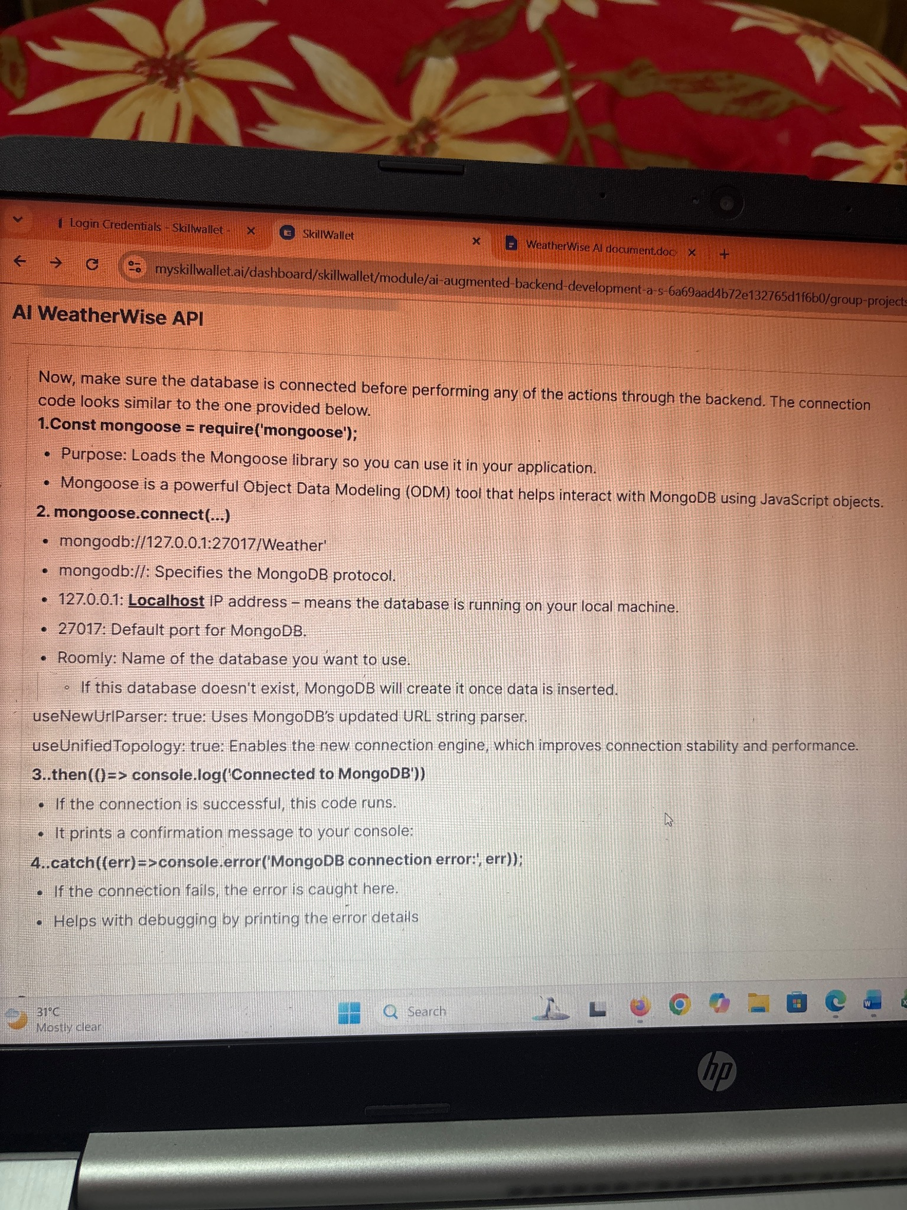

12. Conclusion
Mongoose provides a simple and structured way to connect the AI WeatherWise API to MongoDB. The connection URL identifies the MongoDB server, port, and Weather database. The success handler confirms a valid connection, while the error handler supports debugging when a connection cannot be established. This database connection forms the foundation for the remaining WeatherWise API backend operations.

